**Report**

**Zhengyu Wang**

1. **Introduction**

The data I acquired are places located in Culver City including restaurants, book stores, landmarks and bus stops. I really like Culver City because one of friend has worked in TikTok in Culver City. This time I want to know if there is a kind of public transportation I can take to downtown Culver City. The preparation project taught me how to start research in a specific area like the USC UPC campus and how to acquire various types of data for the same location such as street data, building blocks and land covers. It also taught me to use different tools in ArcGIS, especially the Clip and Minimum Bounding Geometry tool, and how to project a raster layer in to my current map. Moreover, the preparation of dataset provided me with crucial concepts for importing my own dataset in to ArcGIS pro.

1. **Assessment of exemplar project**

I think the outcome of my finishing the exemplar project is quite great. I followed each step of the introduction of project 3 and found difficulties in drawing bounding box. Fortunately, I created a nice boundary at last which ensured the following procedures were correct. Here are my answers to the questions 10.

* 1. OSM layers includes tremendous data not only the buildings. That’s the reason why I failed to export the data of my project in OpenStreetMap at first. It contains a large of amount of data so if the area you draw is too big, you cannot export it easily. However, the LA GeoHub layers of building footprints contains buildings only. OSM contains rich geodata uploaded by people in the world. LA GeoHub focuses on LA area. After fully checked these two layers, I found the layer provided by LA GeoHub is more completed than OSM’s one. Here is the comparison (Figure 1 and Figure 2)

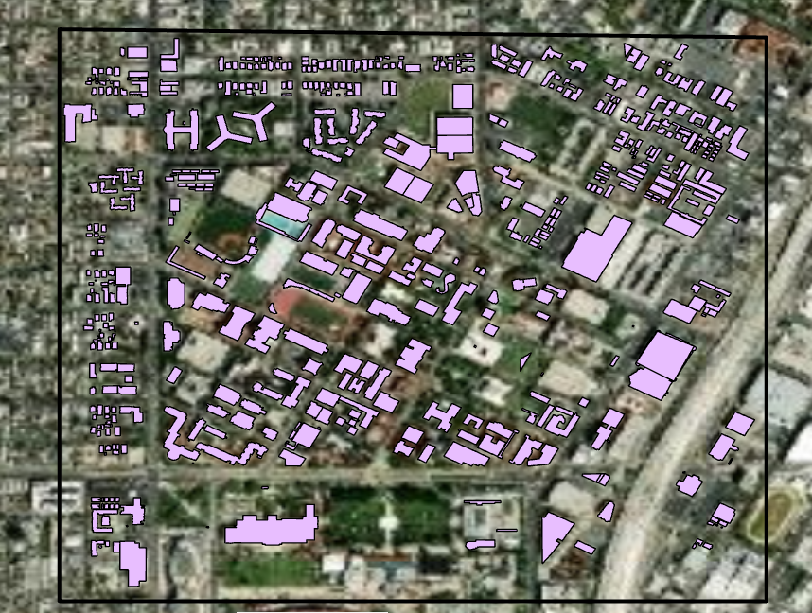

Figure 1. the OSM layer of building footprints

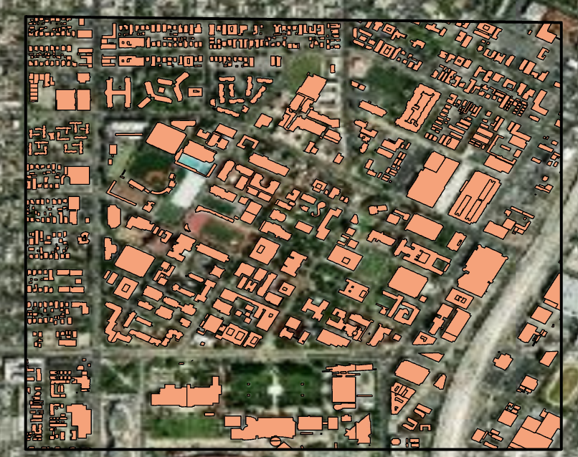

Figure 2. the LA GeoHub layer of building footprints

* 1. Building footprints are presented as polygons in map. They are building blocks. However, the geotagged points of addresses are points located at specific buildings (Figure 3).

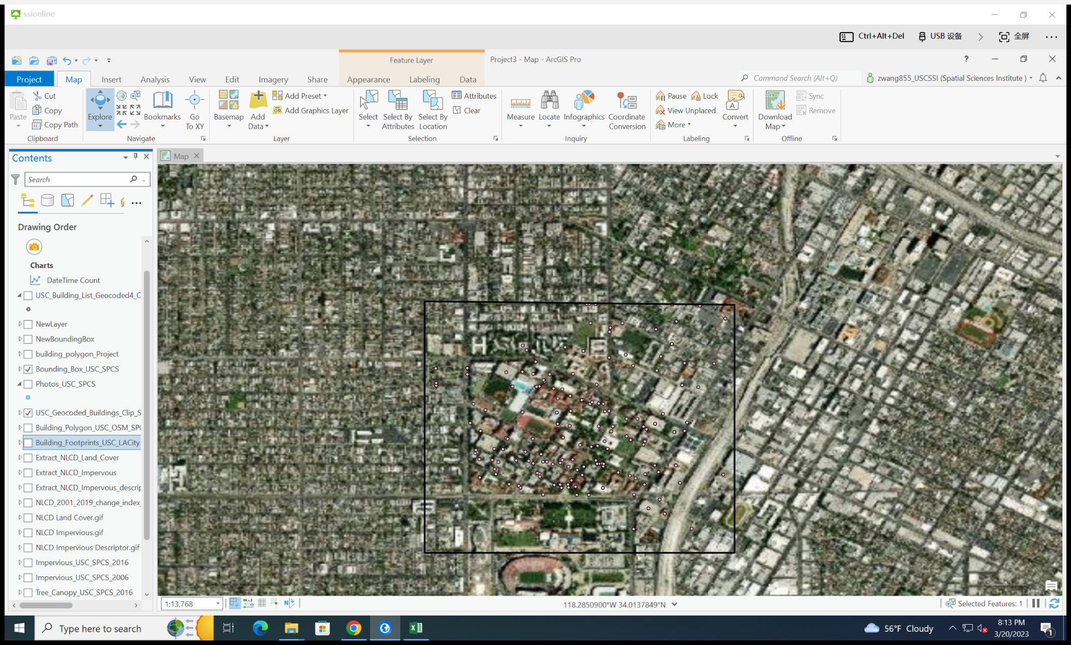

Figure 3. geotagged points of addresses.

* 1. If the surface of one area is impervious, the area cannot grow trees or the canopies of trees are short. The darker the layer of impervious surface, the shallower the layer of tree canopy (Figure 4 and Figure 5).

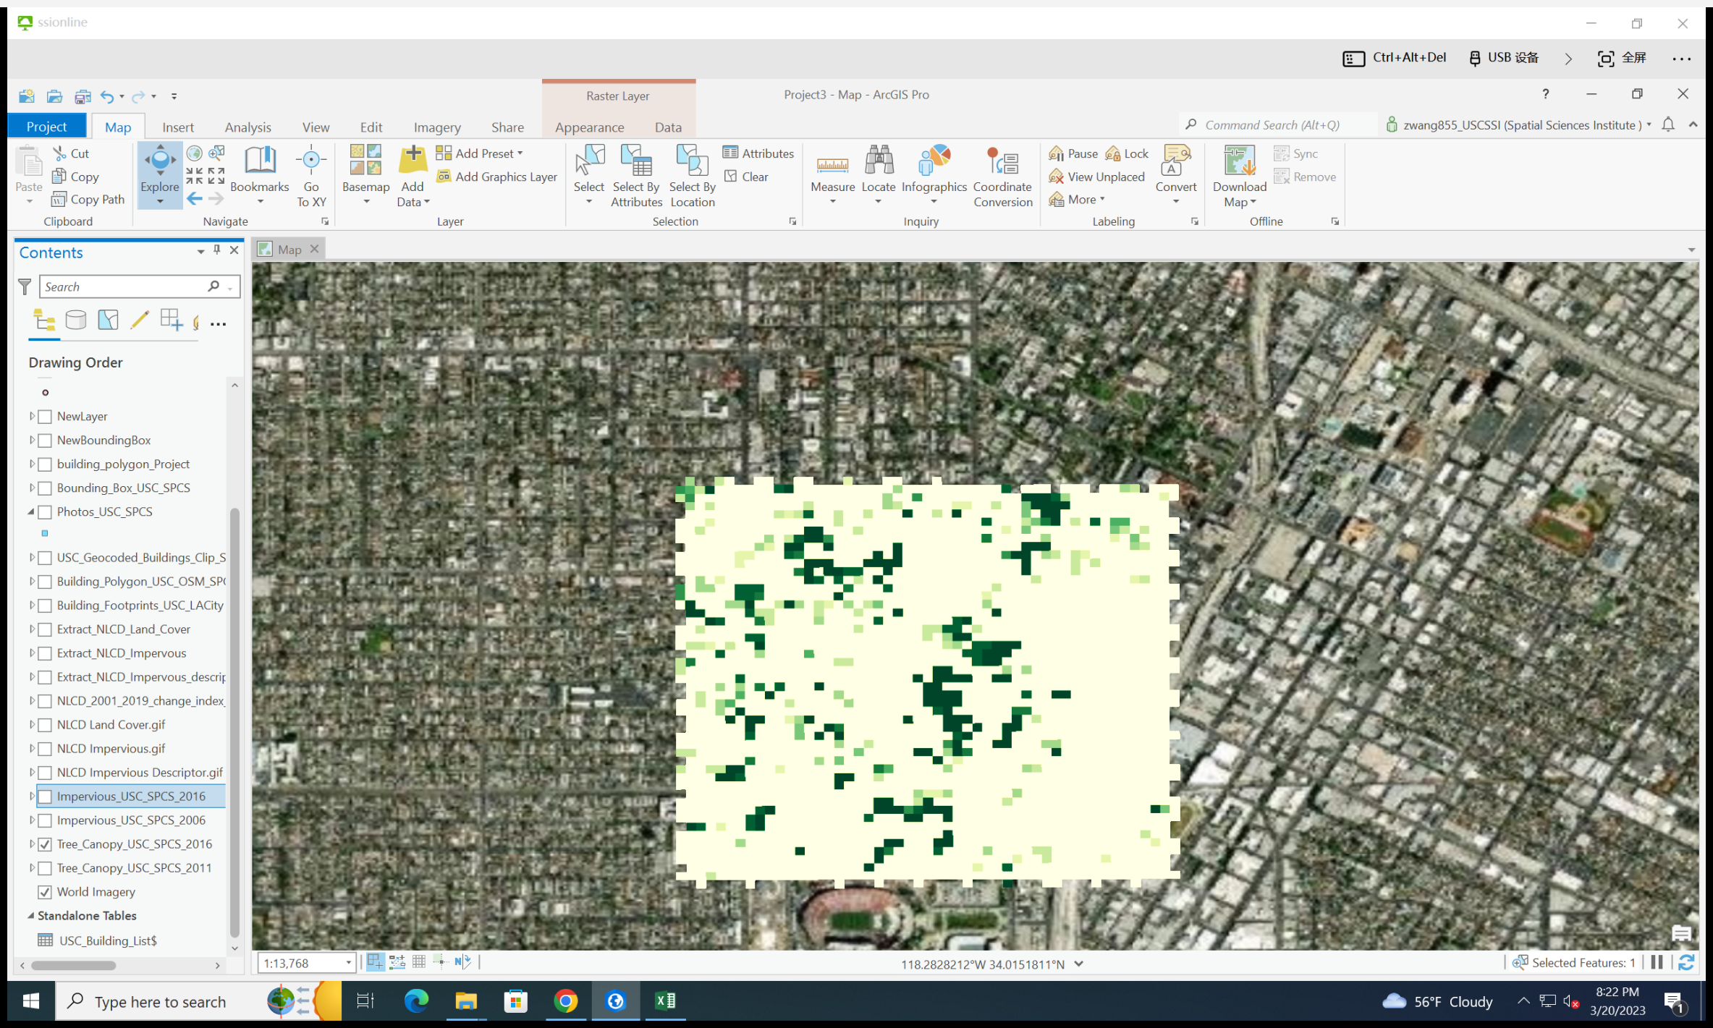

Figure 4. the layer of tree canopy

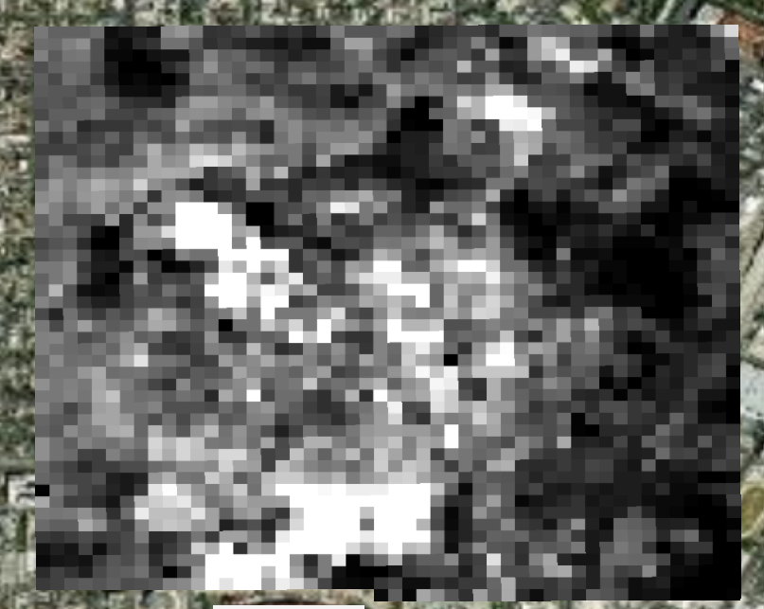

Figure 5. the layer of impervious surface 2019

Comparing the layers of impervious surface(Figure 5 and Figure 6), we can conclude that the impervious surface has increased. Through the temporal information about the building layers, we can find the number of buildings increased and maybe that’s the reason why impervious surface increased.

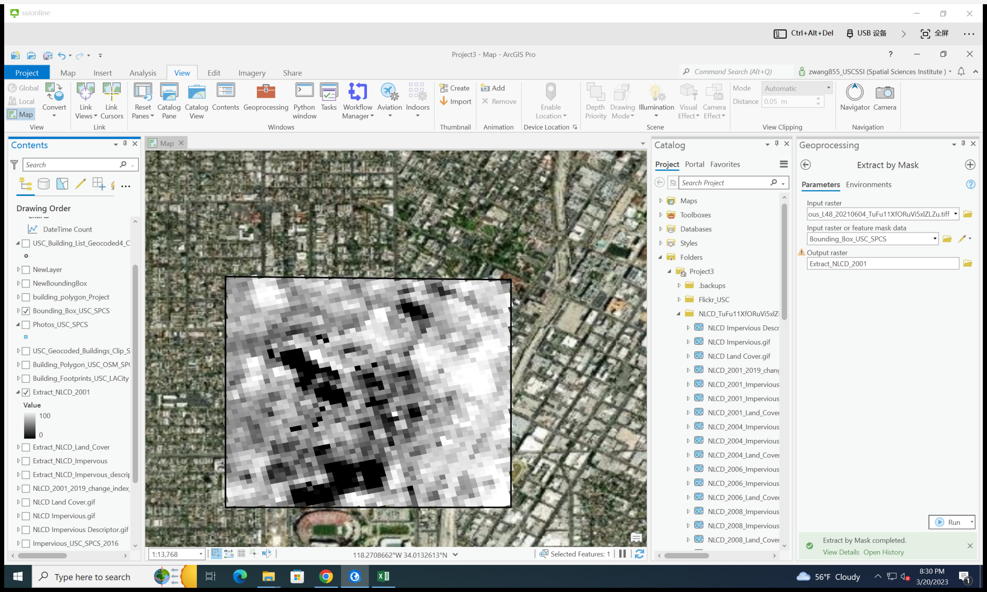

Figure 6 the layer of impervious surface 2001

* 1. The pop-ups of the photos can help us identify surroundings of one specific area so that we can observe clearly whether a building is located there, which can help us to figure out if the surface is pervious or not.
  2. The goal of this project wants to figure out the relationships of buildings and surface and how it changes over time. The counts of animals may be helpful for the research because it can apparently shows the change of land use, which is related to the surface conditions.

1. **Study area and coordinate system**

The are of the preparation project centered on the University of Southern California University Park campus, which is located in the center of LA and the southeast of downtown LA. It’s the main campus of USC which contains almost all schools and ancient buildings. The boundary of the preparation project includes UPC of USC, USC village and areas near them (Figure 7).

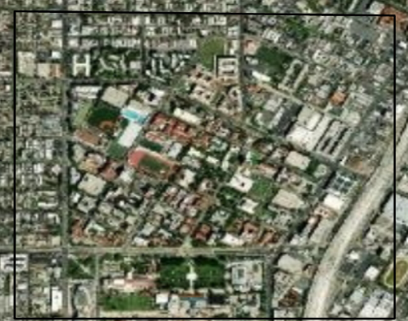

Figure 7. the study area of the preparation project

The area of my project is downtown Culver City. It’s a place which has diverse collection of outdoor cafes, various shopping markets, galleries and several traditional landmarks. It’s in the southwest of LA, which is not far for us to go the Santa Monica. The boundary of my project is a rectangular area where the downtown Culver City is in the center(Figure 8). I chose NAD 1983 (2011) StatePlane California VI FIPS 0406 (US Feet) as the projected coordinate system. Because this PCS is focused on California and used for defining and stating positions or locations of points on the surface of the earth within the State of California, which is suitable for this project.

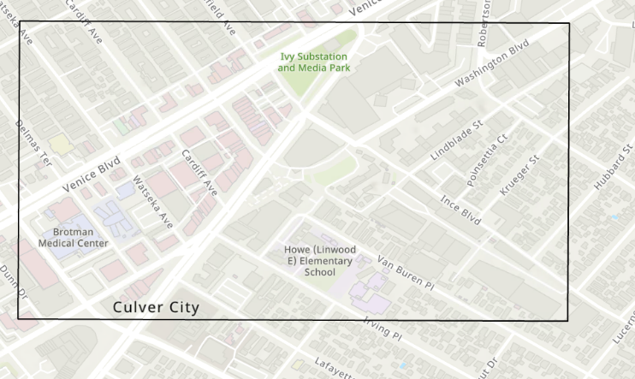

Figure 8. the study area of my project

1. **Data Acquisition and Preparation**

I have searched data for several websites such as CulverCityBus.com, Google Map and CulverCity.org, finding street address and name of the places and then stored them into Excel. To make the dataset be available in ArcGIS, I sorted the data and labeled these data

* 1. The busstops of metro line 1(Figure 9)
     1. Description:

This dataset is the busstops of metroline 1, which includes many the main stops of this line on the way to Culver City. It can help us to identify whether we can take bus to downtown Culver City.

* + 1. Creator: Me

I accquired it from <https://www.culvercitybus.com/Bus-Schedules/Line-1-Washington-Blvd>

* + 1. Format: the file of Excel, and no coordinate system
    2. Ontology:

The ‘Name’ is the name of the bus stop; it’s non-address information and Street_Address is the address of each stop; it’s address information. I also add city and state to each row of this data set so that I would be better for me to import it into ArcGIS.

* + 1. Steps:

I search every stop at Google to find its street address. After uploading these data into Excel, I gave heads of each colomn so that they can be categorized and understood by ArcGIS(Figure 9). After add it to ArcGIS, I used the tool named “Convert a table to locations on the map”(Figure 10).

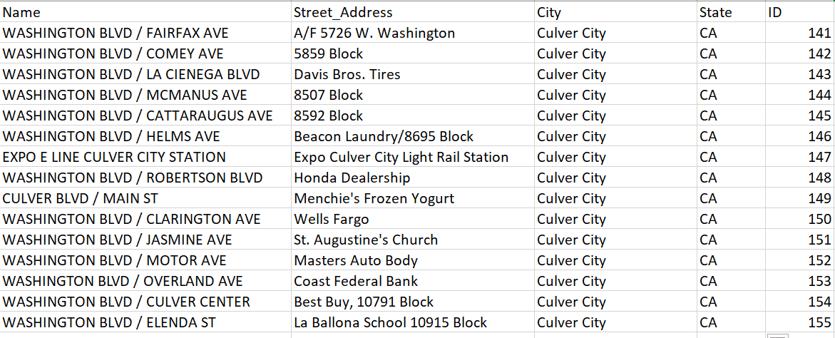

Figure 9. Excel spreadsheet with Bus Stops of Metro Line 1

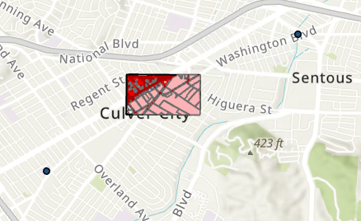

Figure 10 converted data of Metro Line 1

Unfortunately, the converted data doesn’t match the map very well(as you can see there are only two points near the study area and no point is in that zone, some of them are in other states).

* 1. Places in the Bounding Box
     1. Description:

This dataset includes restaurants, stops and other places in this area, which provides crucial information if we want to go to downtown Culver City.

* + 1. Creator:

Me. I aqcuired it from Google Map

URL:<https://www.google.com/maps/place/Culver+Blvd.+%26+Duquesne+Ave./@34.0224922,-118.399571,17z/data=!4m10!1m2!2m1!1sbus+stop!3m6!1s0x80c2ba28eb95eb83:0x25a6684c7a4f61f0!8m2!3d34.0209283!4d-118.3970295!15sCghidXMgc3RvcJIBCGJ1c19zdG9w4AEA!16s%2Fg%2F1th5_1jv>

* + 1. Format: file of Excel
    2. Ontology:

It also contains Name, Street addres and other location information. Name is the name of each places;it’s non-address information. Street_Address is the location where they are located;it’s address information.

* + 1. Steps:

I search important or famous place at Google Map and note their locations. After uploading these data into Excel, I gave heads of each colomn so that they can be categorized and understood by ArcGIS(Figure 11). After add it to ArcGIS, I used the tool named “Convert a table to locations on the map”(Figure 12).

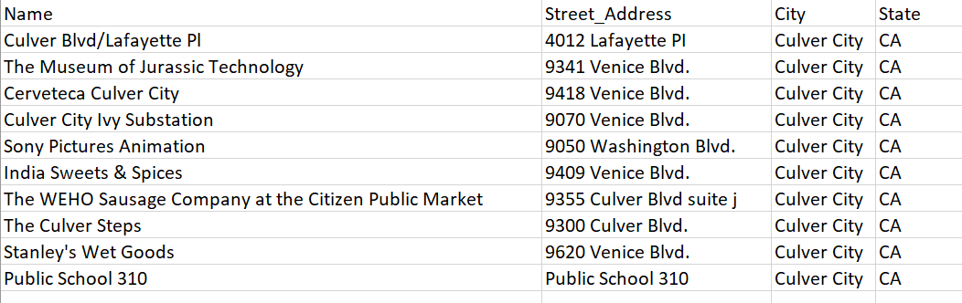

Figure 11. Excel spreadsheet with Places in the Bounding Box

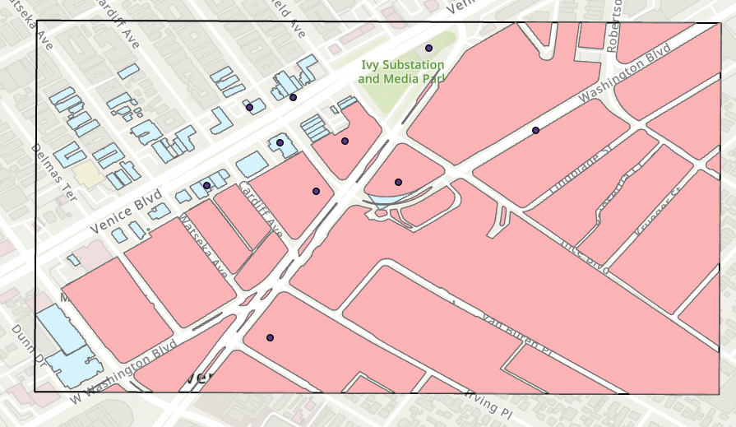

Figure 12. Converted data of places in downtown Culver City

* 1. Culver City Open Data
     1. Description

These datasets contains many geodata of Culver City, which includes blocks, boundaries of blocks, centerlines and edge of pavement. It can tell us the many features of Culver City like the freeways and the land use.

* + 1. Creator

It’s created by city departments especially the department of Culver City.

URL: <https://www.culvercity.org/Explore/City-Maps>

* + 1. Format:

It has various type of geodata such as SHP File, SBX File, CPG File and PRJ File

* + 1. Ontology

Every subfile is different than one another. Some of them are shapefiles and some of them are database files.

* + 1. Steps

I searched them on official website and download the open GIS dataset (Figure 13 and Figure 14). After that, I added the folder into the folder of my project, and projected them to the chosen PCS. Finally, I use Clip tool to make the data display in the bounding box.

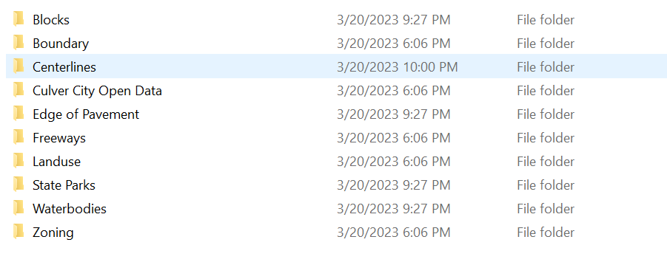

Figure 13 the package of Culver City Open Data

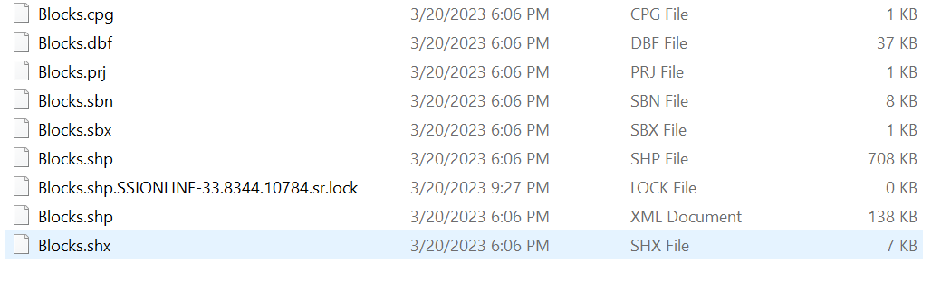

Figure 14 the contents of each subpackage

* 1. Parking lots
     1. Description

This dataset includes main parking lots in downtown Culver City. It can tell us the location of parking lots and their price per two hours.

* + 1. Creator

Me.

I acquired the data from <https://en.parkopedia.com>

* + 1. Format

File of Excel

* + 1. Ontology

The name of the parking lot is non-address information and the Street Address is the address information of each parking lot. The Price is economic information.

* + 1. Steps

I search important or famous place at parkopedia and stored important information in Excel. After uploading these data into Excel, I gave heads of each colomn so that they can be categorized and understood by ArcGIS(Figure 15). After add it to ArcGIS, I used the tool named “Convert a table to locations on the map”(Figure 16)

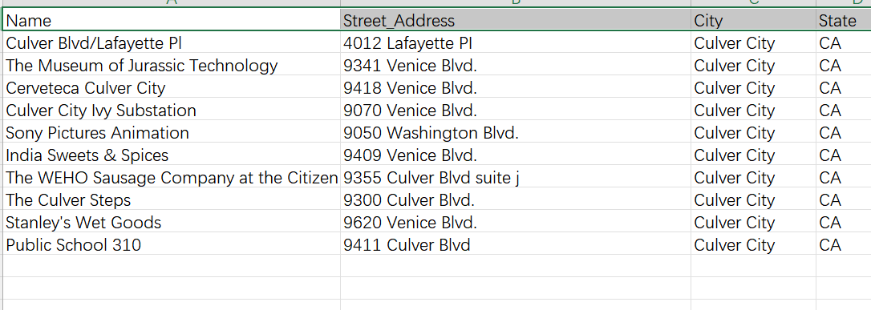

Figure 15 Excel spreadsheet of Parking lots in downtown Culver City

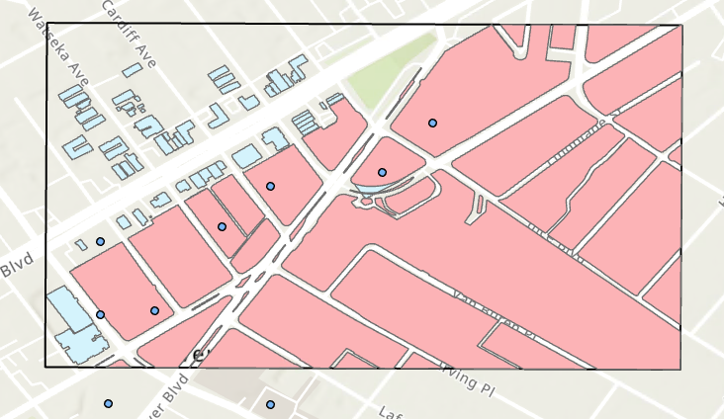

Figure 16 Parking lots in downtown Culver City

1. **Discussion**

I made several mistakes when building boundary for my study area. Initially the tool named “Create Feature Class tool” is a little bit obscure because I don’t know which feature should I create and whether should I use another Feature Class as a template. Fortunately, I finished at last, and use different way to create another bounding box. Finding data is another procedure that took me a long time. Because I had to insert data line by line manually and made sure they are in the study area. I estimated the location of each data before I wrote them down in the Excel. It would be better for me to find adequate data before I chose the boundary of study area. When geocoding the data, It would be better to the format of the street address, which is the essential information for ArcGIS to match the data to my map. These dataset may be not helpful for scholars to do some research, but it can help someone who wishes to go to downtown Culver City and spend a nice weekend. After bringing these data together (Figure 17), I found the famous or higher rated restaurants and shops are located near garages. Maybe people use less public transportation especially in LA. I drew a line to illustrate the school district which starts from the lower left corner to the upper lines of the boundary, and I found these shops are located near the margin of this district.

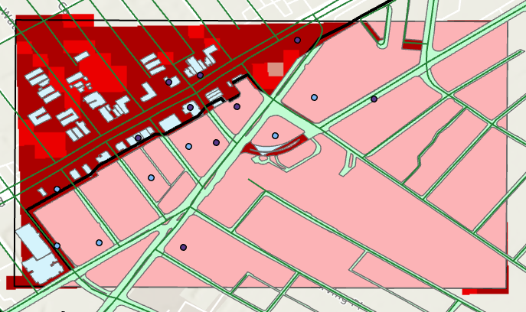

Figure 17. the final map of the project